**Tema**

Videojuegos

**Modelo ER**

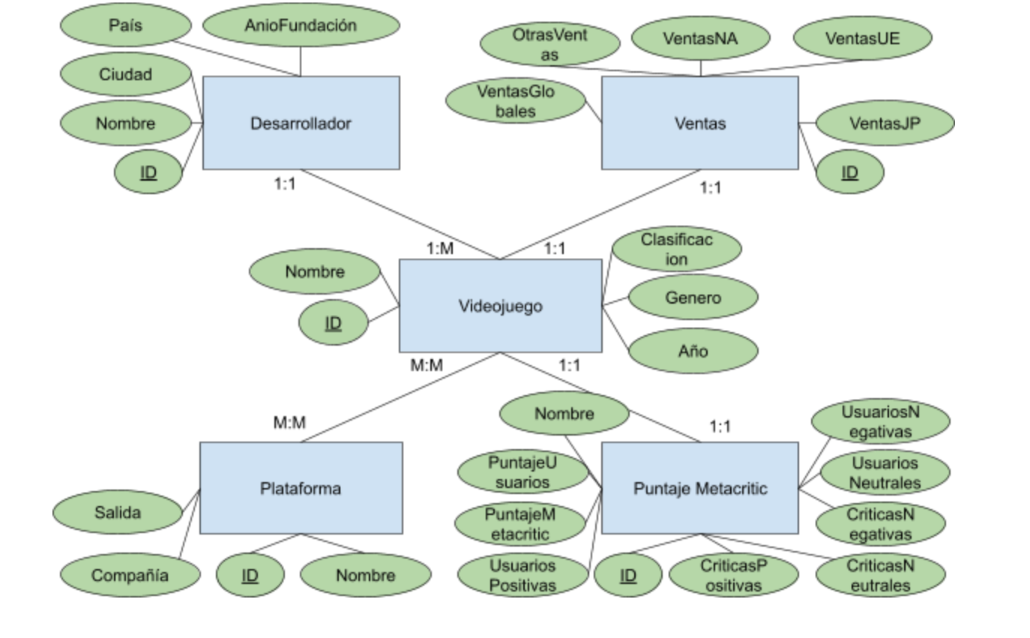

Diagrama de Base de Datos

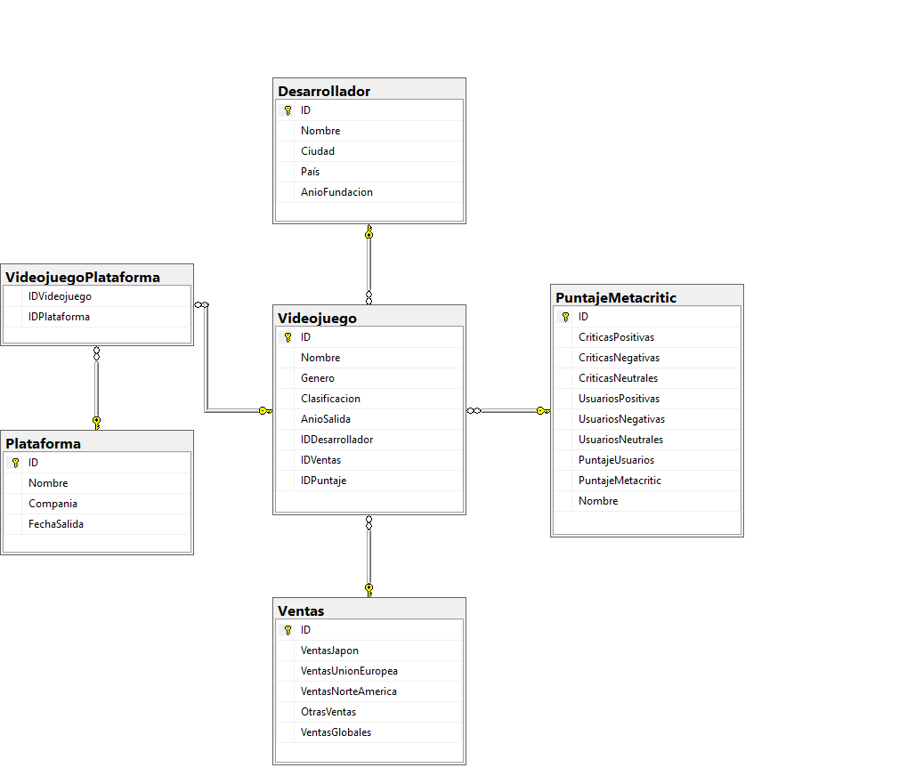

URL de dataset

<https://www.kaggle.com/upadorprofzs/eda-video-game-sales/data>

<https://www.kaggle.com/skateddu/metacritic-games-stats-20112019>

<https://www.kaggle.com/andreshg/videogamescompaniesregions>

<https://www.kaggle.com/luismartingrados/videogames>